**SECTION A-46 MARKS**

**Attempt** all **questions in this section.**

1. Define the term Transition element. (01 mark)

…………………………………………………………………………………………………………………………………………………………………………………………………………………………………………………………………………………………………………………………………………

1. Explain two reasons why transition elements form complexes. (02 marks)

…………………………………………………………………………………………………………………………………………………………………………………………………………………………………………………………………………………………………………………………………………

1. Name the following complexes. (@01 mark)
2. [FeOH(H2O5]2+

…………………………………………………………………………………

1. Cr(H2O)6Cl3

…………………………………………………………………………………

1. K4Fe(CN)6

…………………………………………………………………………………

1. The activity of Bismuth was reduced by $\frac{1}{4}$ in 40 minutes. Determine its half-life. (02 marks)

……………………………………………………………………………………………………………………………………………………………………………………………………………………………………………………………………………………………………………………………………………………

………………………………………………………………………………………………………………………………………………………………………………………………………………………………………………………………

1. Complete the following nuclear equations. (@01 mark)
2.  ……………………. +
3. +  …………..  2𝛂
4. Give one application of radioactivity. (0½ mark)

………………………………………………………………………………………………………………………………………………………………………….

1. Complete the following equations and in each case state the name of the main products. (@01½ marks)
2. H2C=CHCH2OH …………………………………………..

Name: …………………………………………………………………………

1. CH3CH2COOH + C2H5OH ………………………......

Name: …………………………………………………………………………

1.  ………………………………………………

Name: …………………………………………………………………………

1. Name the reagent(s) that can be used to distinguish between the nitrate, NO3- & nitrite, NO2- ions. (01 mark)

………………………………………………………………………………………………………………………………………………………………

1. State what would be observed if a solution of the ions is treated with the reagent (s) you have named in (a) above. (02 marks)

………………………………………………………………………………………………………………………………………………………………………………………………………………………………………………………………………………………………………………………………

1. Draw the structure and name the shape of the following ions. (@01½ marks)

|  |  |
| --- | --- |
| Ions | Shape |
| NO3- |  |
| NO2- |  |

1. Write electronic configuration of iron. (0½ mark)

………………………………………………………………………………

1. Iron (III) chloride was dissolved in water and solution tested with litmus paper. State what was observed and explain your answer. (03 marks)

………………………………………………………………………………………………………………………………………………………………………………………………………………………………………………………………………………………………………………………………

1. Complete the following equations and in each case, write an accepted mechanism for each reaction. (@03 marks)
2. CH3CHO + NaHSO3  ………………………………
3. CH3CH(Cl)CH(Cl)CH3 ……………………………..
4. The standard electrode potentials of two half-cells are given in below.

H+(aq) /H2(g) 0.00V

Cd(s) /Cd2+(aq) 0.40V

1. Write the cell notation for the cell formed by combining the two half-cells. (01 mark)

……………………………………………………………………………………………………………………………………………………………………

1. Write ionic equation for the: (@01 mark)
2. Reaction at cathode.

……………………………………………………………………………………………………………………………………………………………………

1. Reaction at anode.

……………………………………………………………………………………………………………………………………………………………………

1. Overall cell reaction.

……………………………………………………………………………………………………………………………………………………………………

1. Define the **order of reaction**. (01 mark)

…………………………………………………………………………………………………………………………………………………………………………………………………………………………………………………………………………………………………………………………………………

1. The experimental results in the table were obtained for the reaction between nitrogen monoxide gas and oxygen gas.





1. Determine the **order of reaction** with respect to:

Nitrogen monoxide. (01 mark)

…………………………………………………………………………………………………………………………………………………………………………………………………………………………………………………………………………………………………………………………………………

Oxygen. (01 mark)

…………………………………………………………………………………………………………………………………………………………………………………………………………………………………………………………………………………………………………………………………………

1. Write the **rate equation** for the reaction. (0½ mark)

……………………………………………………………………………………………………………………………………………………………………

1. Calculate the: (@0½ mark)
2. **Overall order of reaction**.

…………………………………………………………………………………………………………………………………………………………………………………………………………………………………………………………………………………………………………………………………………………………………………………………………………………………...

1. **Rate constant** for the reaction and **state its S.I unit**.

……………………………………………………………………………………………………………………………………………………………………………………………………………………………………………………………………………………………………………………………………………………………………………………………………………………………

**SECTION B-54 MARKS**

**Attempt** ANY **SIX questions in this section.**

1. What is meant by the term thermosoftening plastics? (01 mark)
2. Name two thermosoftening plastics. (01 mark)
3. The structural formula of the polymer, Synthetic rubber is:
4. A sample of soap was produced from 20g of vegetable oil containing an ester of heptadecanoic acid (C16H33COOH) & concentrated potassium hydroxide solution. Calculate the mass of soap formed. (03 marks)
5. State what would be observed and write equation for the reaction that place if:
6. Using equations only, show how the following compounds can be synthesized.
7. Define the term enthalpy of formation. (03 marks)
8. What is meant by the term buffer solution? (03 marks)
9. What is meant by the term ionization energy? (02 marks)
10. Define the term empirical formula. (01 mark)
11. State three conditions for the manufacture of sulphuric acid. (03 marks)

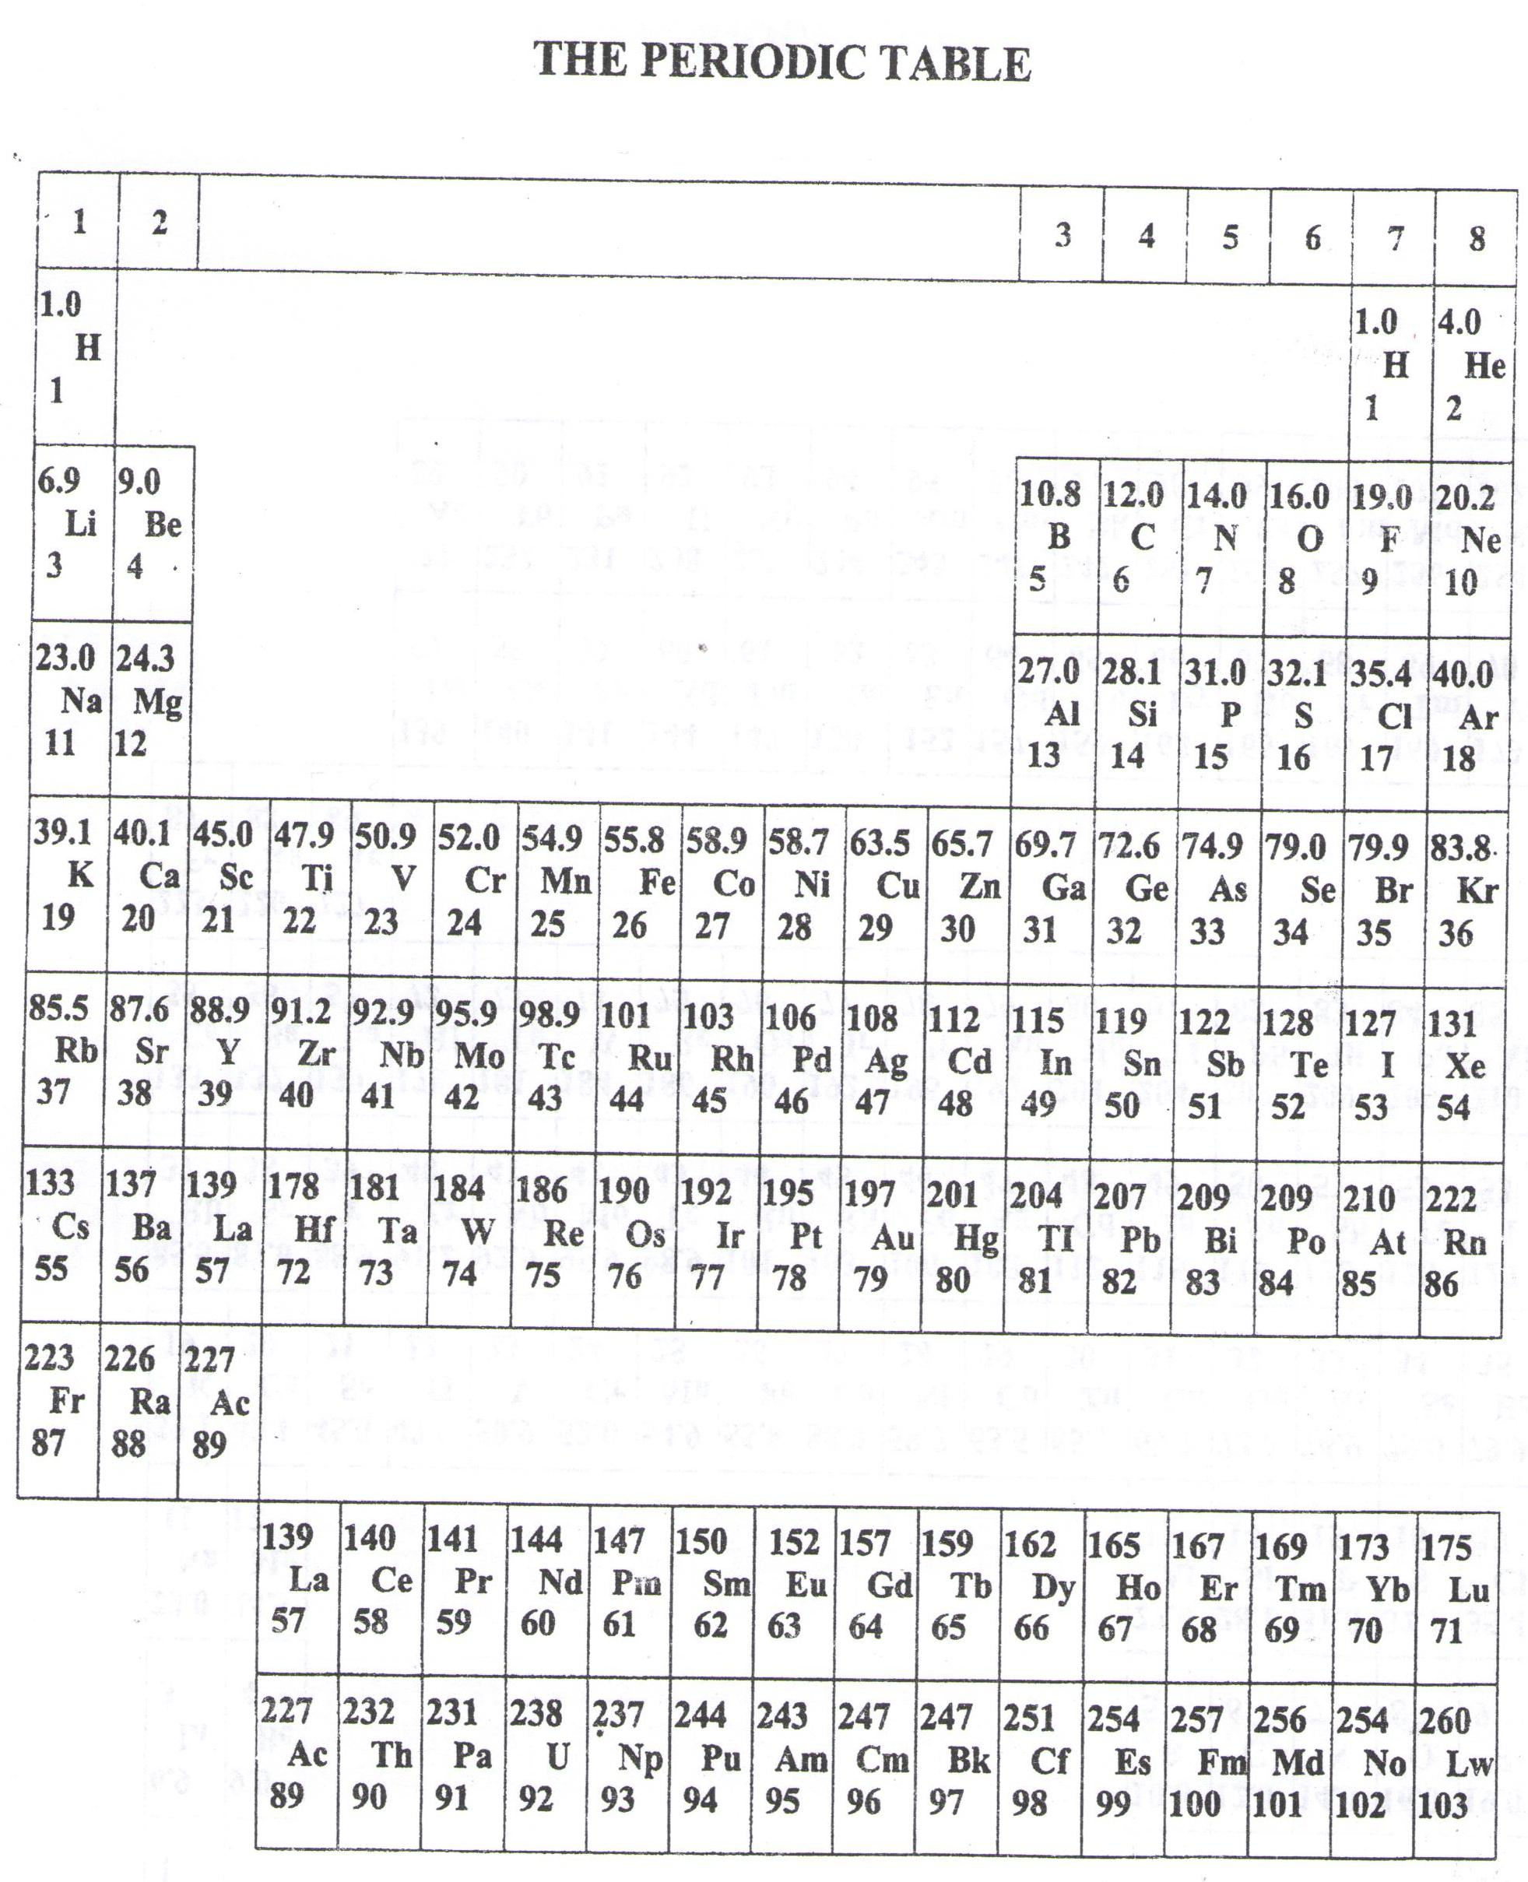

* ===END===

WELCOME TO SENIOR SIX, YEAR 2023

This is the last page of the printed paper, Page 22